**Physical Data Model**

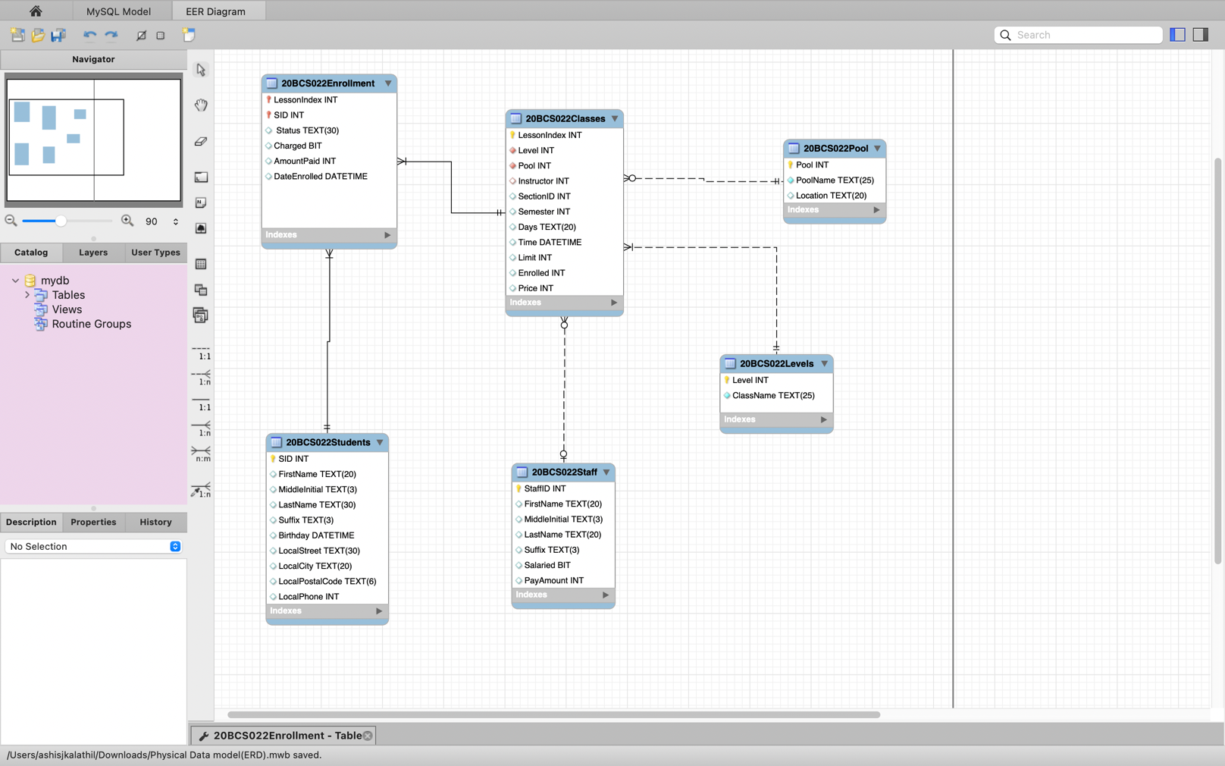

|  |
| --- |
|  |
| *a. A pool may or may not ever have a class.* |
| *b. The levels table must always be associated with at least one class.* |
| *c. The staff table may not have ever taught a class.* |
| *d. All students must be enrolled in at least one class.* |
| *e. The class must have students enrolled in it.* |
| *f. The class must have a valid pool.* |
| *d. The class may not have an instructor assigned.* |
| *e. The class must always be associated with an existing level.* |

* Classes_Levels Relationship

One class shouls have one level and only one level

A level can have one or many classes

* Classes_Pool Relationship

One class should have a pool and only one pool

A pool can have no class or many classes

* Classes_Staff Relationship

One class should have one and only one advisor

A staff could have no classes or many classes

* Classes is related to student by the relation table enrolment

One class should have atleast one to student but can have many

A student should have one class but also can have many classes

***4. List the weak entity, if exists? Convert them to Strong entity wherever possible in your Physical data model. Create additional Tables if required.***

**Weak entities**

Here the entity that could be weak is enrolment but that could be made strong by adding combination of 2 foreign keys as primary key

|  |
| --- |
| ***5. Physical data model should have minimal scope for data redundancy. Highlight such data redundancy scenarios in your Physical data model Table if it exists.*** |
|  |

ANS:

Currently there isn’t any cases of data redundancy in this ER model but there could be data redundancy if we hadn’t added the relational table “Enrollment” as the relation between classes and students is a many to many relation Data Redundancy could have been occoured